Predictions on day 1 for the next whole week (using the data till 19/04/2020)

Degree - 4

Day 1 – 20/04/2020

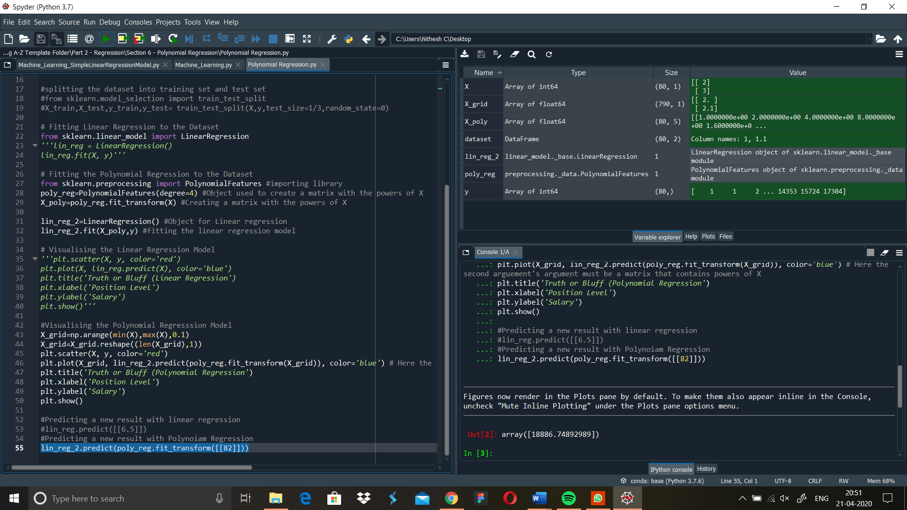

Prediction: - 18886

Day 2 – 21/4/2020

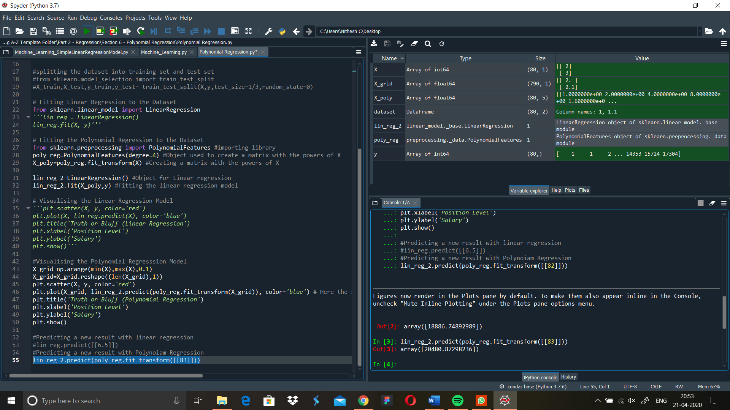

Prediction: - 20480

Day 3-22/4/2020

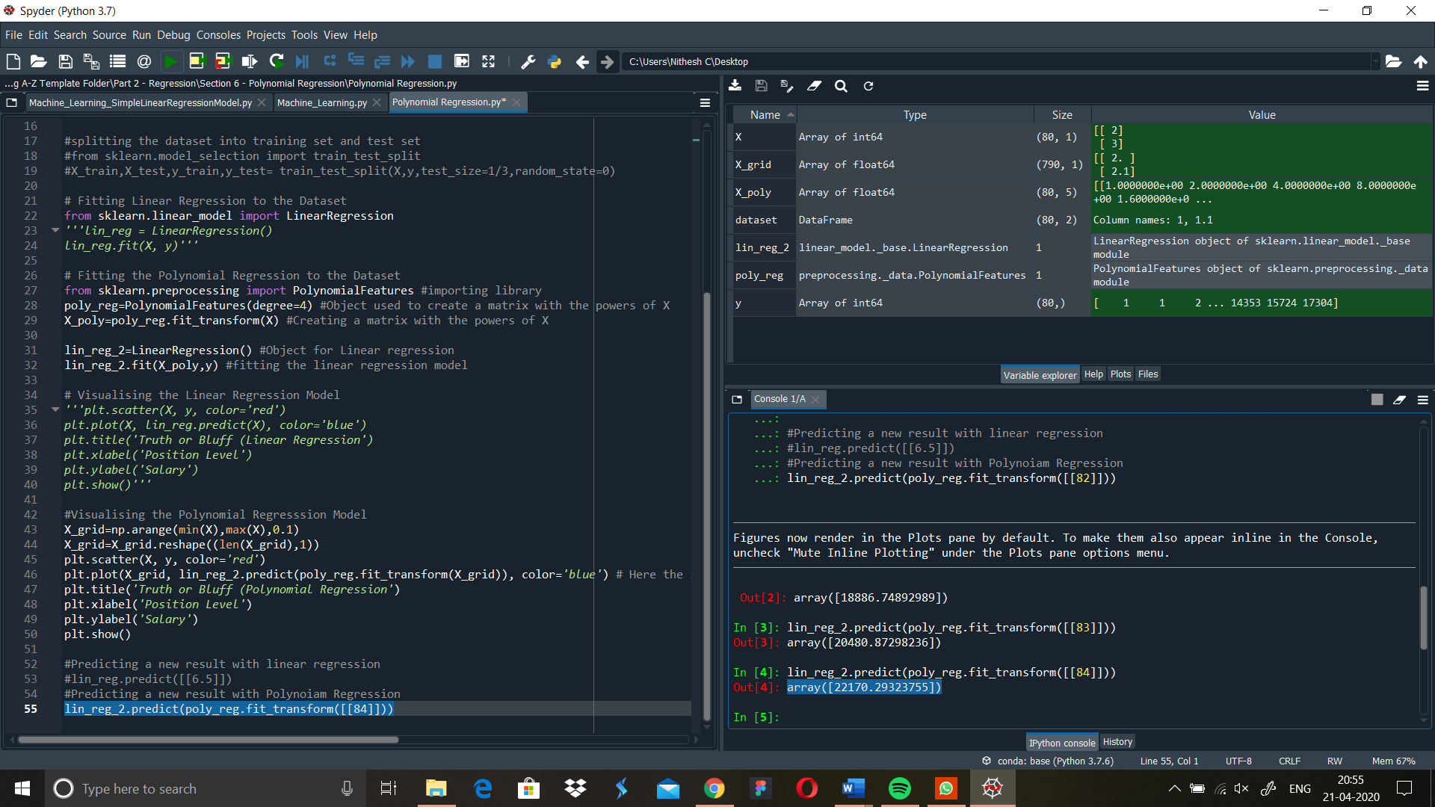

Prediction: - 22170

Day 4-23/4/2020

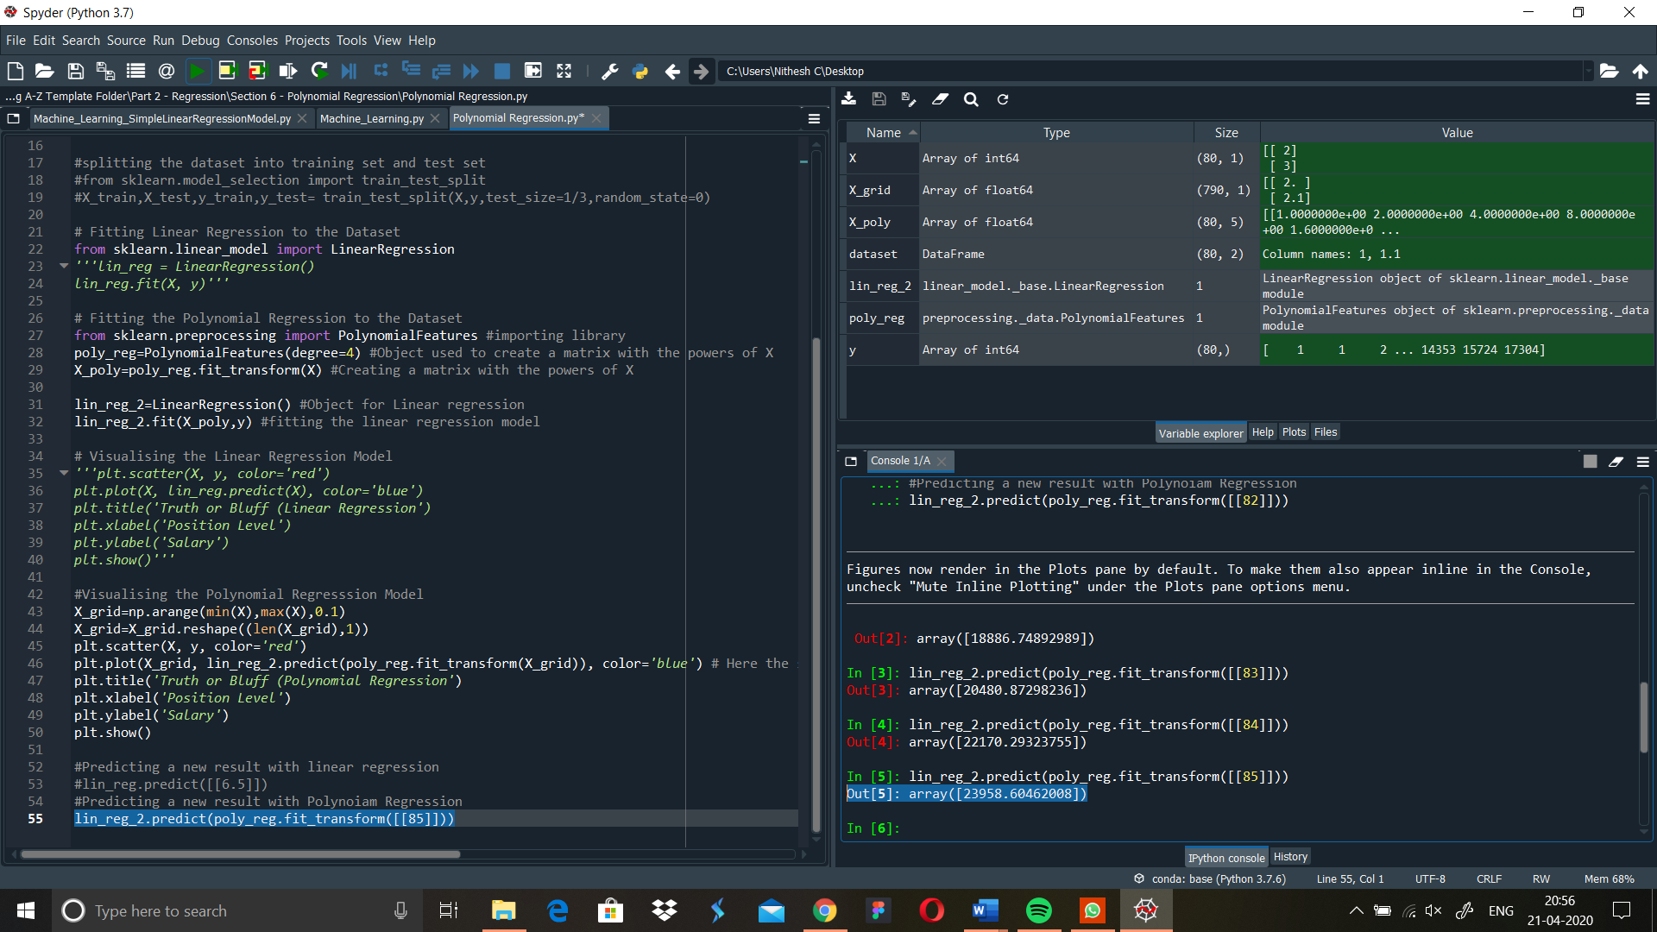

Prediction: - 23958

Day 5-24/4/2020

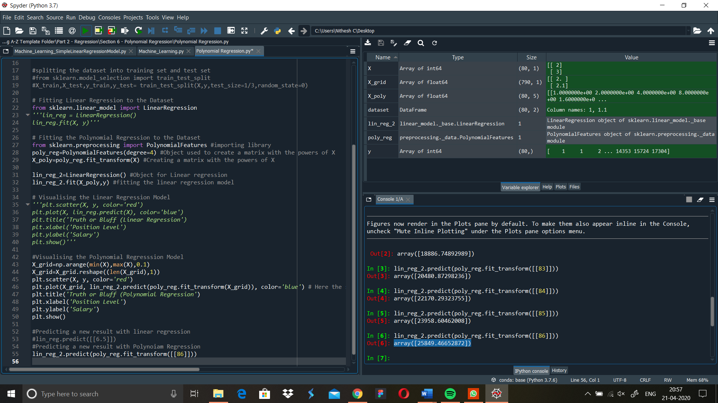

Prediction: - 25849

Day 6-25/4/2020

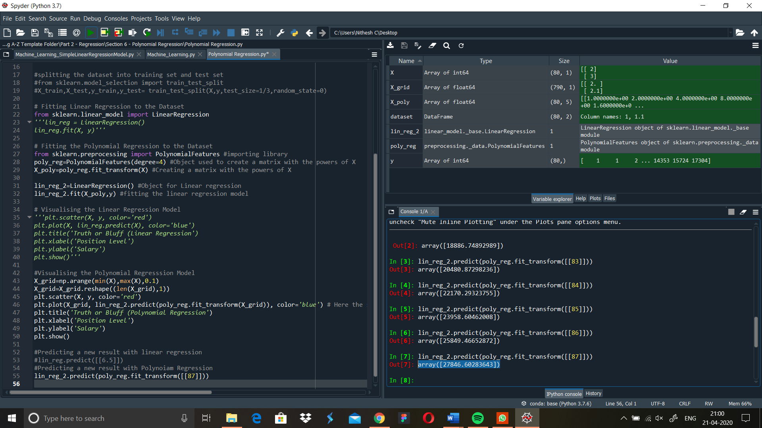

Prediction: - 27846

Day 7-26/4/2020

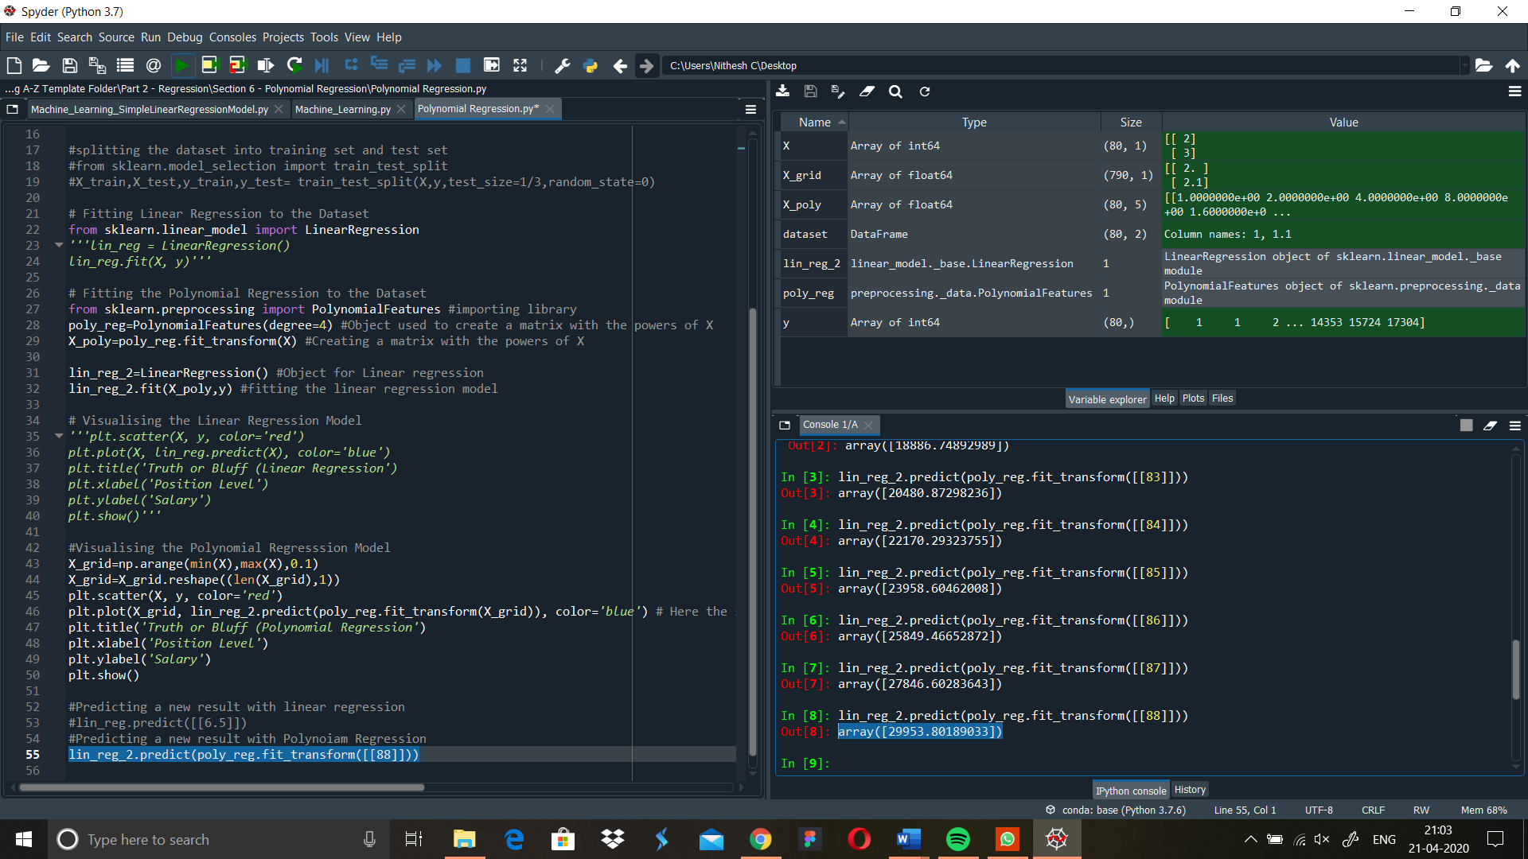

Prediction: - 29953